Title: former version saving

Problem: The former versions may be lost when editing text.

Primary stakeholder: Students or others who need to modify text regularly

Graphical User interface:

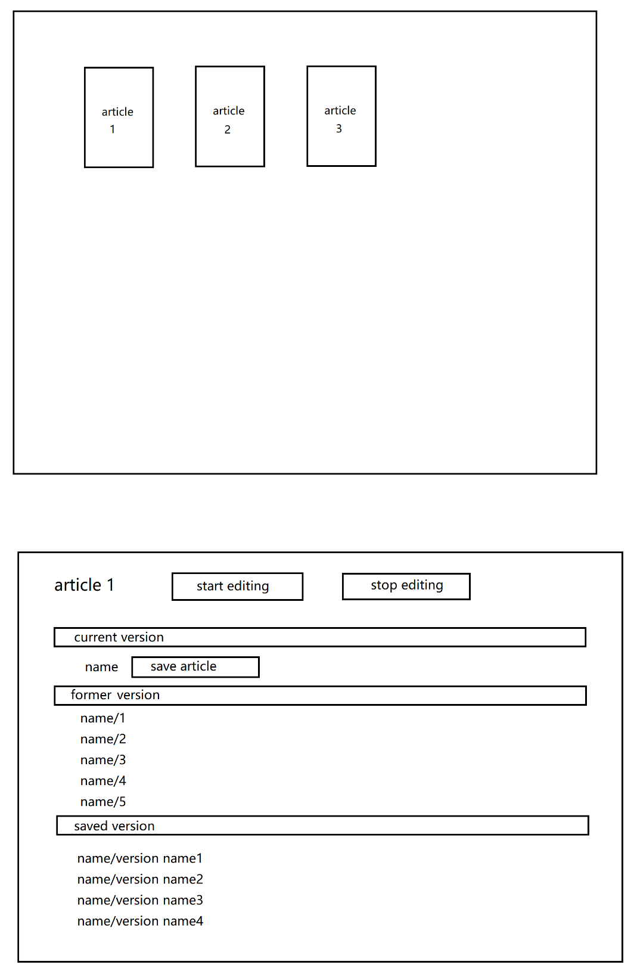

Click every version will open an text(or word) file.

When start editing, program will automatically generates a new file every half hour to save the current content in current version as former version. Program only saves 5 recent former versions.

User can click save article when edit and entry a name to make a saved version with current content.

Data:

String for article name and version name,

Int for version type(current, former, saved) and saving time

Name version name version type saving time

Sample 0 201910312010

Sample 1 201910312000

Sample save1 2 201910312005